Stepper motor tuning
- Motor 17HS08-1004S

Nema 17 Bipolar 1.8deg 13Ncm (18.4oz.in) 1A 3.5V 42x42x20mm

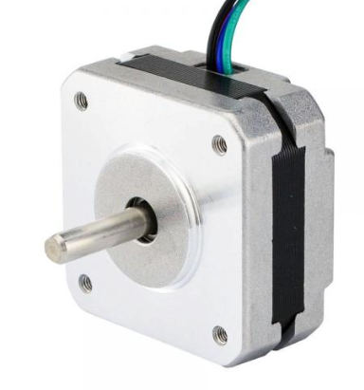
V/$Hz$ | mH | Ohm
.033 | 3 | 3.5

1 amp CONFIG value 12032 dec, gatecfg1 = 0x00EC, gatecfg2 = 0xE1 (14680300 dec combined)
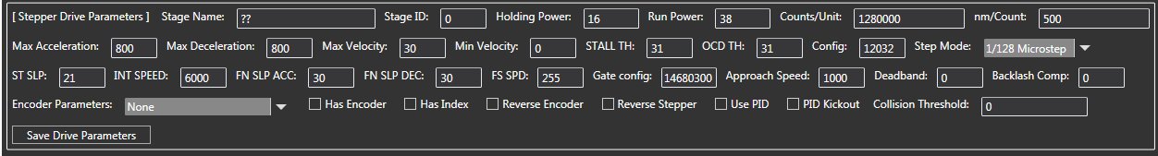

- Motor 8HS11-0204S

Nema 8 Bipolar 1.8deg 1.6Ncm (2.3oz.in) 0.2A 4.8V 20x20x28mm

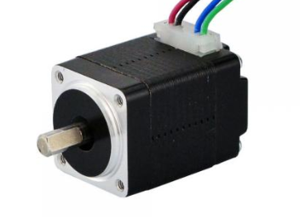

V/$Hz$ | mH | Ohm
.0118 | 30???guess | 24

.6 amp CONFIG value 12032 dec, gatecfg1 = 0x00EC, gatecfg2 = 0xE1 (14680300 dec combined)
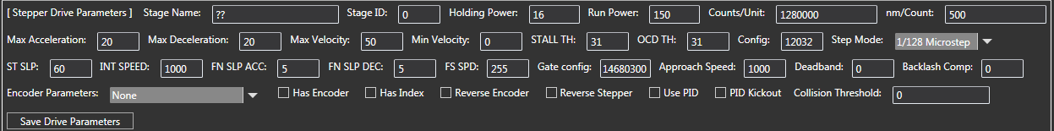

Note: on this motor changing the current (KVAL_RUN) from 80 to 200, tuning was still good
- LIN 4418S-51D-02RO
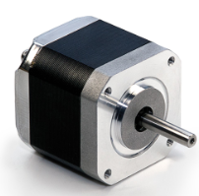

Vs | Holding Current | Run Current | Step/s | holding torque ( oz-in)
24 | .5 | 1 | 500 | 61

V/$Hz$ | mH | Ohm
.042 | 6.55 | 4.25

1 amp large fet CONFIG value 0x1F00 (7936 dec) gatecfg1 = 0x00EC, gatecfg2 = 0xE0 (14680300)
762 Steps/sec
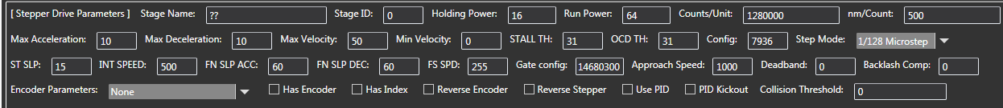

2.14 amp large fet CONFIG value 0x1F00 (7936 dec) gatecfg1 = 0x00EC, gatecfg2 = 0xE0 (14680300)

